TC-REF-005
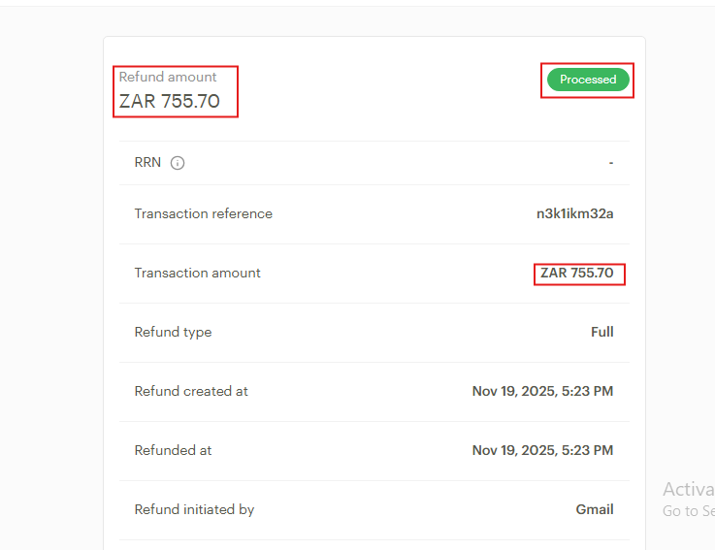
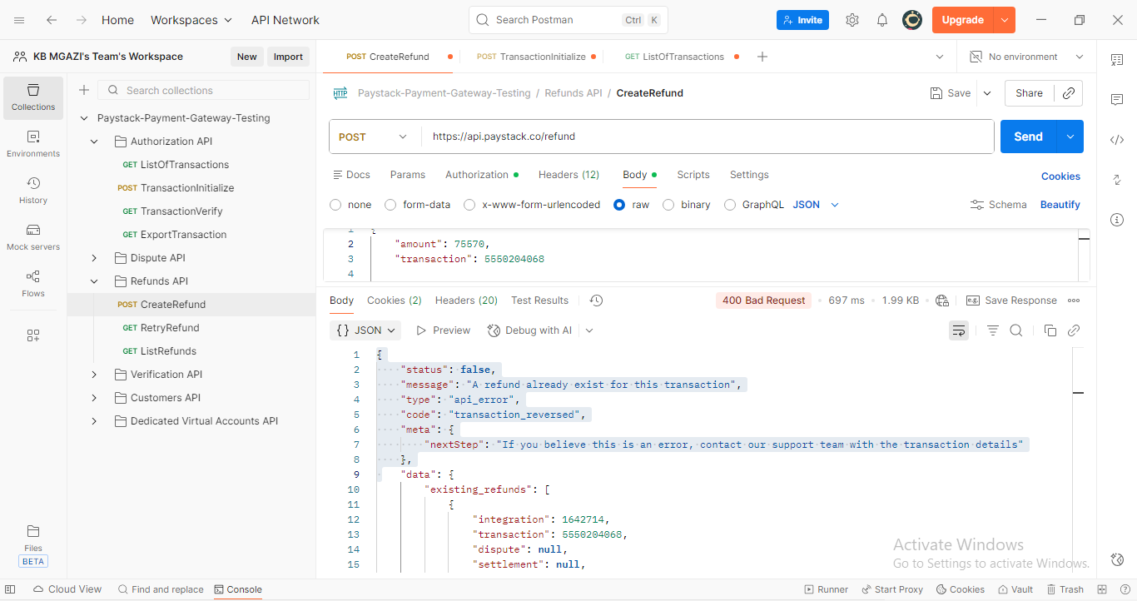

Request:
{
"amount": 75570,
"transaction": 5550204068

}

Response:
{
"status": false,
"message": "A refund already exist for this transaction",
"type": "api_error",
"code": "transaction_reversed",
"meta": {
"nextStep": "If you believe this is an error, contact our support team with the transaction details"
},
"data": {
"existing_refunds": [
{
"integration": 1642714,
"transaction": 5550204068,
"dispute": null,
"settlement": null,
"id": 15920084,
"domain": "test",
"currency": "ZAR",
"amount": 75570,
"status": "processed",
"refunded_at": "2025-11-19T15:23:25.000Z",
"expected_at": "2025-12-05T15:23:25.000Z",
"channel": "manual",
"refunded_by": "gmail",
"customer_note": "Refund for transaction n3k1ikm32a",
"merchant_note": "Refund for transaction n3k1ikm32a by mgazikb@gmail.com",
"deducted_amount": 75570,
"fully_deducted": 1,
"createdAt": "2025-11-19T15:23:25.000Z",
"updatedAt": "2025-11-19T15:23:25.000Z",
"bank_reference": null,
"reason": "PROCESSED",
"customer": null,
"initiated_by": "gmail",
"session_id": null
}
]
}
}

